LINUX COMMANDS ( PRACTICE )

du,df,uname,hostname

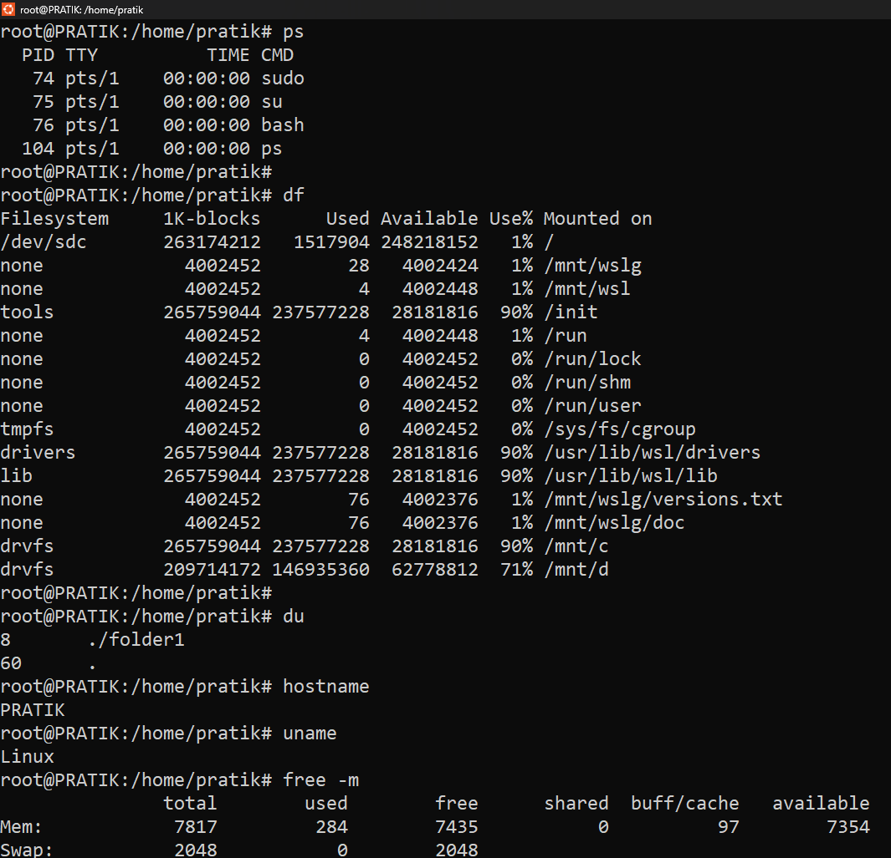

more ,less ,chmod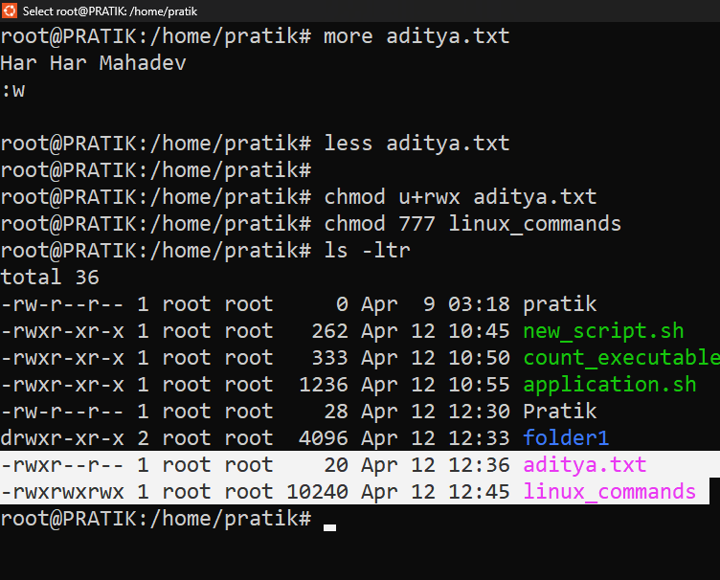

Ifconfigeth0, ifconfiglo,netstatrn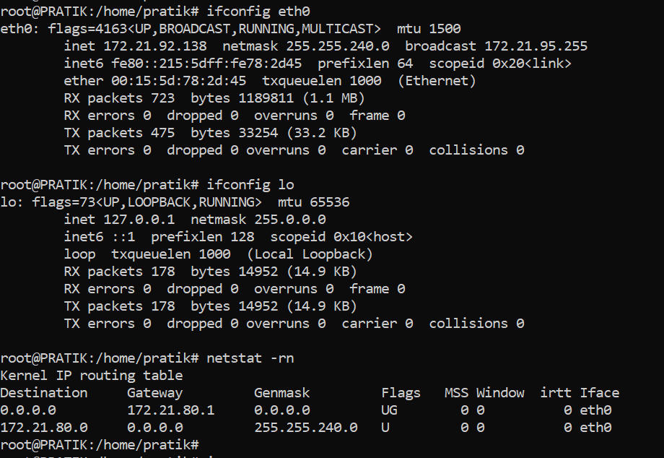

Mtr , whois

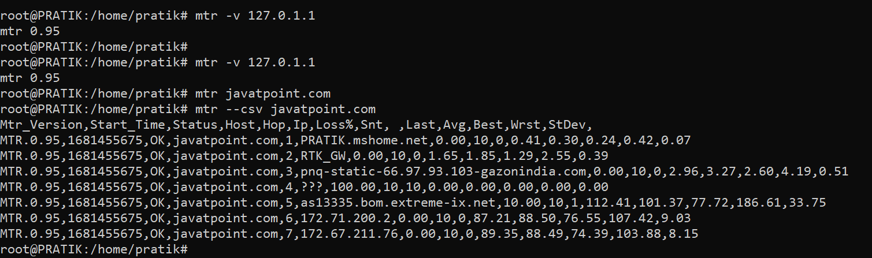

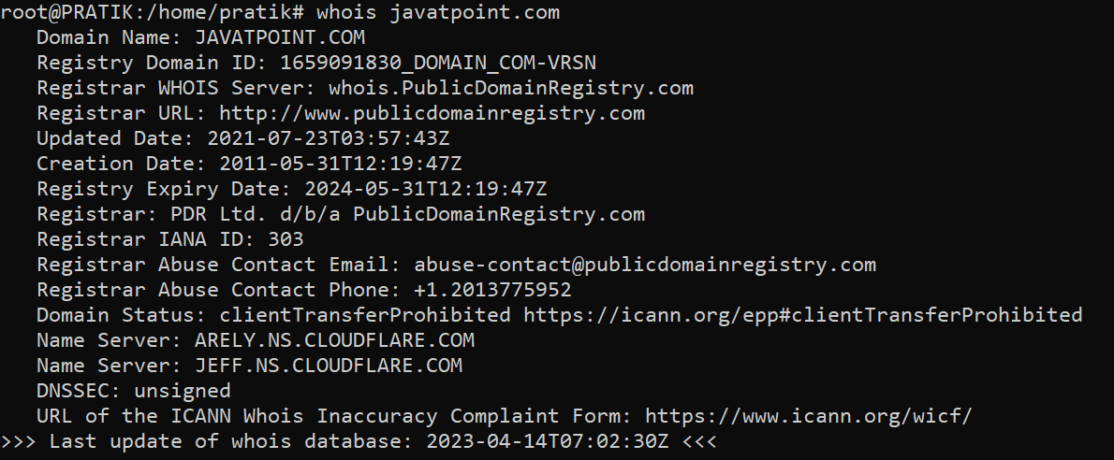

Tac, man, useradd

